**PREREQUISITES**

|  |  |
| --- | --- |
| Team ID | PNT2022TMID008806 |
| Project name | Hazardous area monitoring for industrial power plants using IOT |

IBM Cloud Services

Creation of IBM cloud account

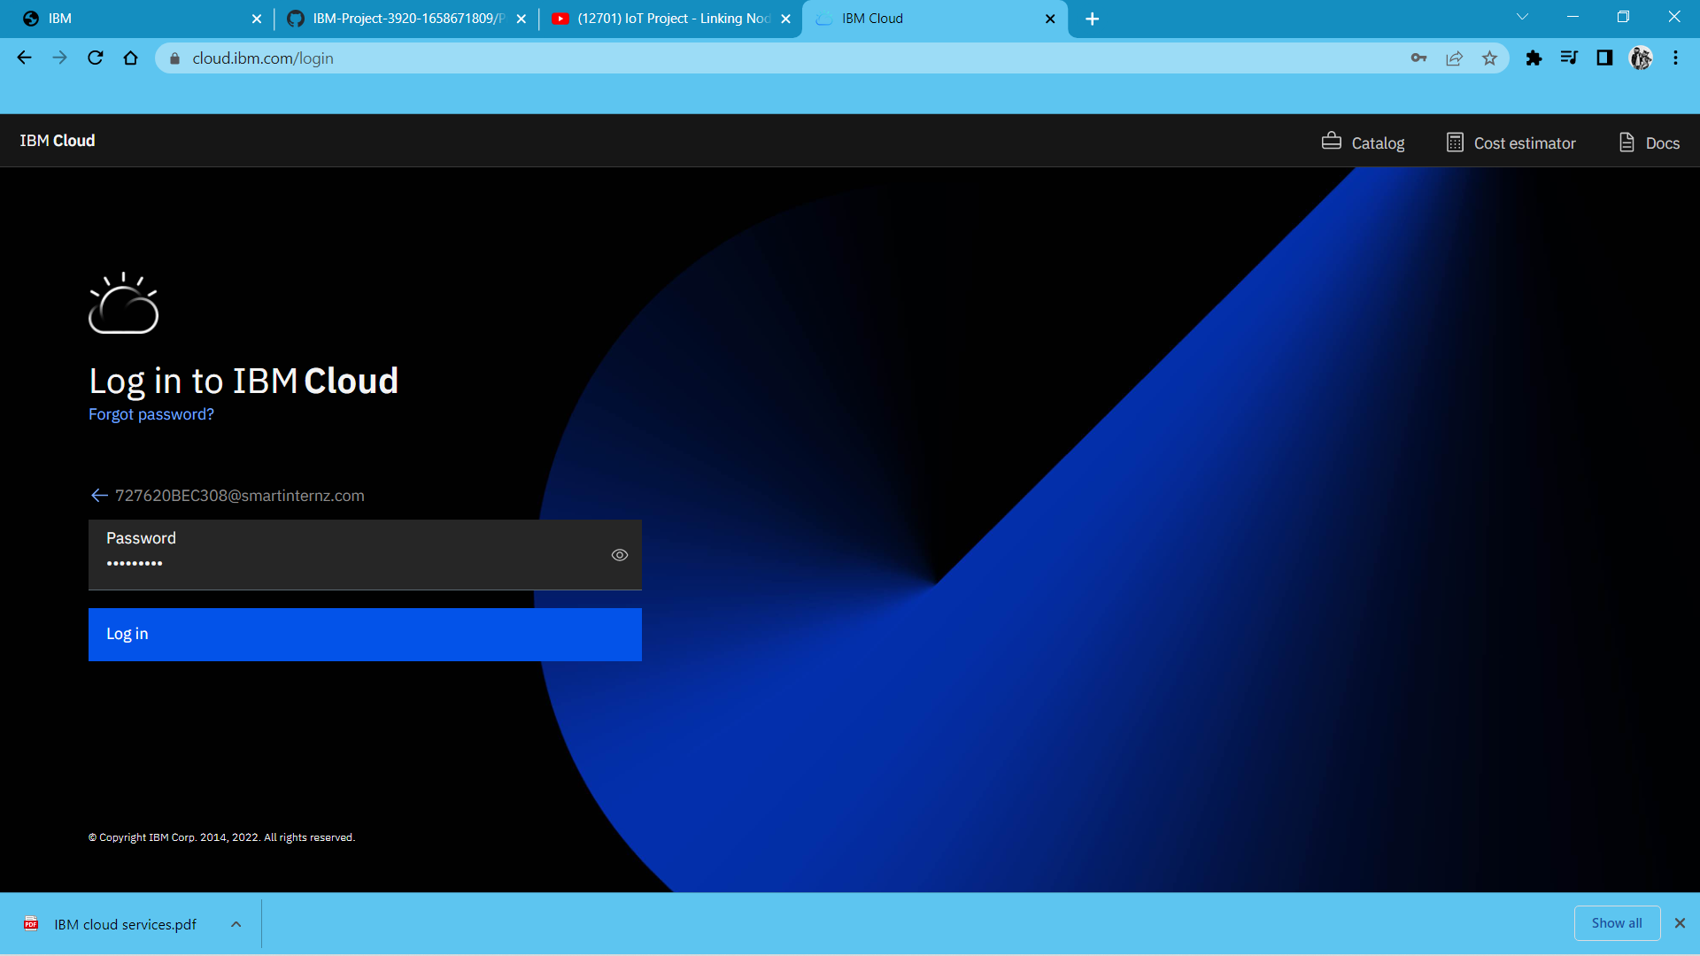

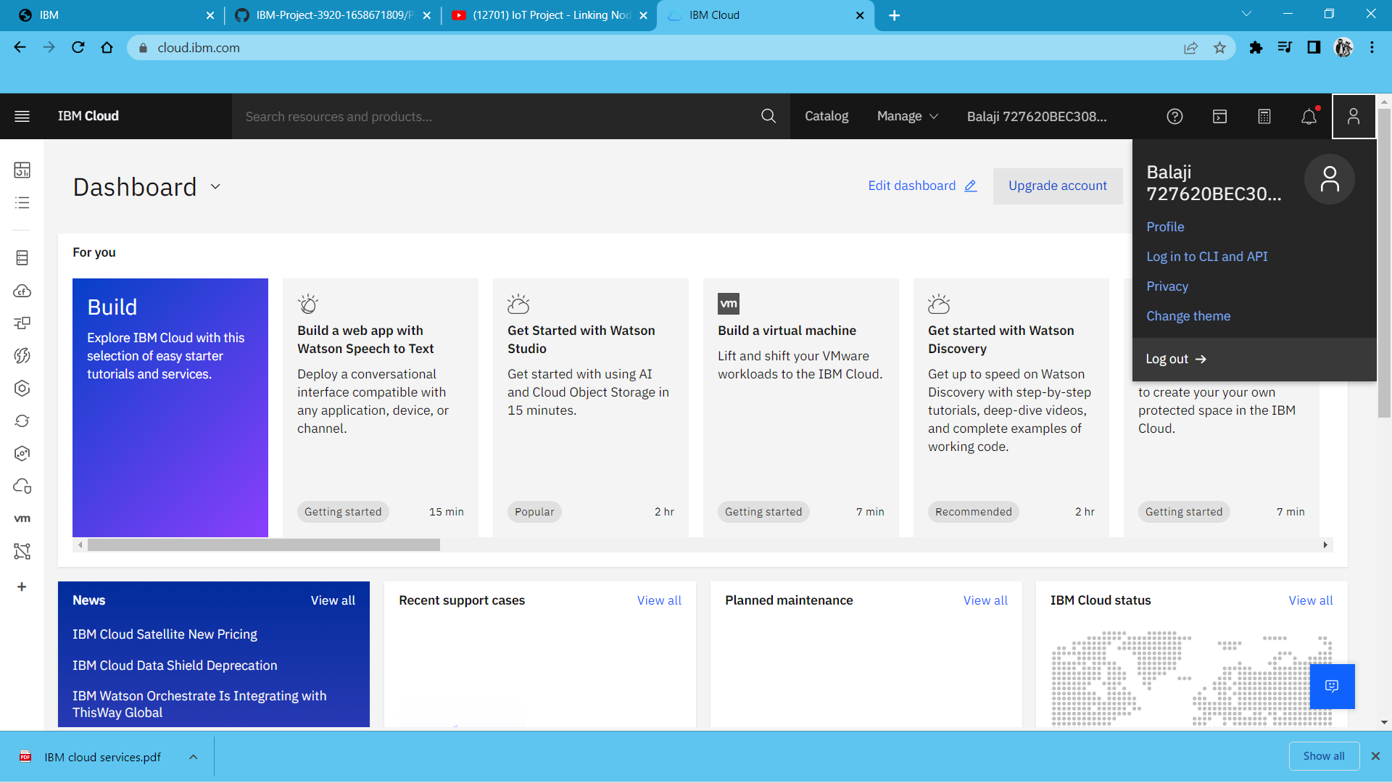

1. Creation of IBM Watson IOT platform:

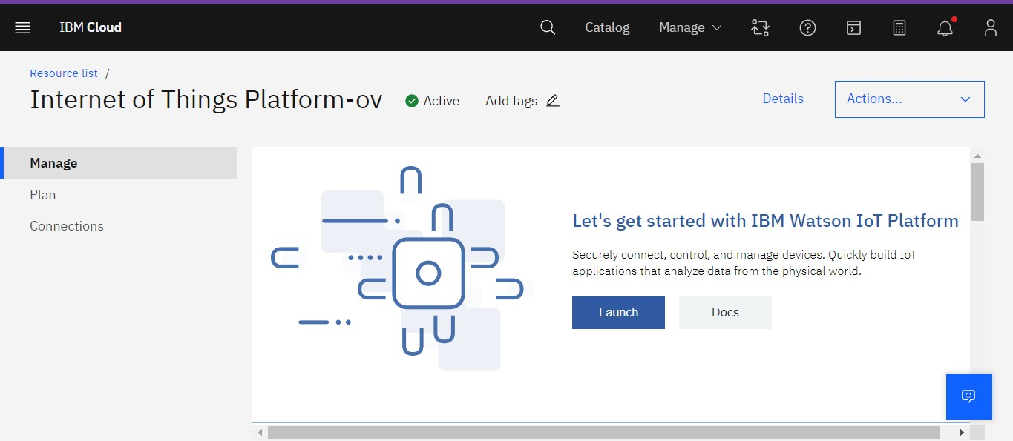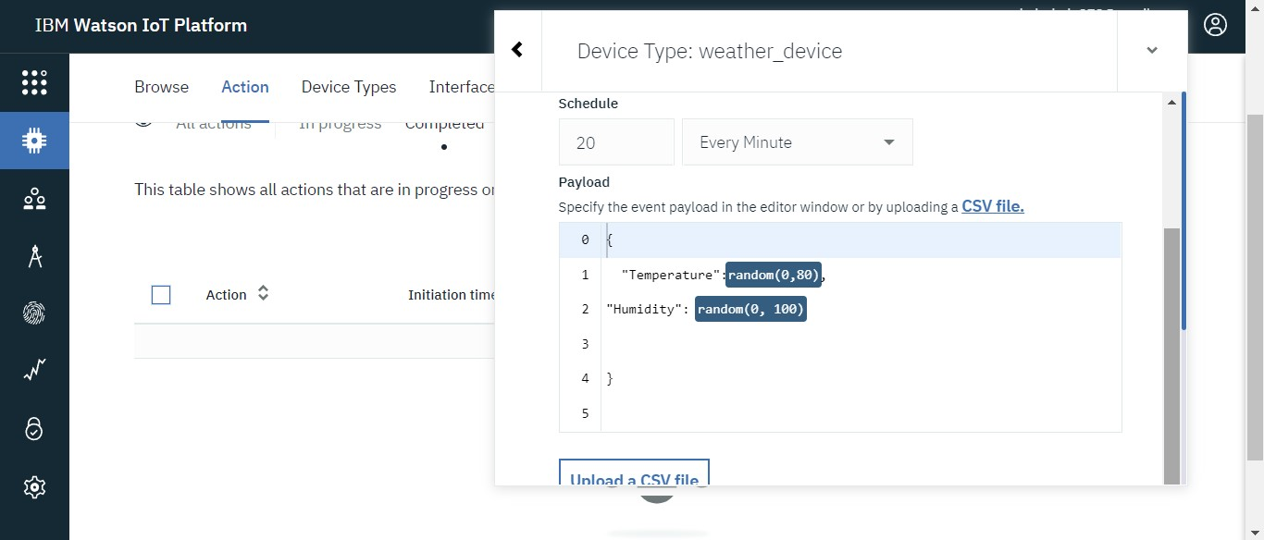

2.Creation of Node-Red Service

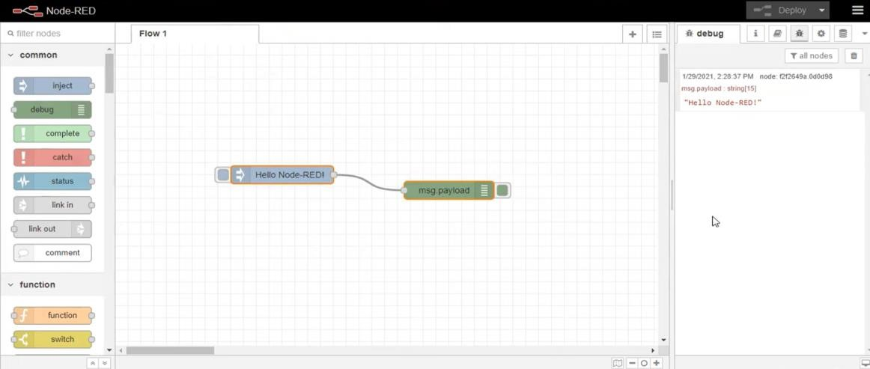

3.Creation of Cloudant Database:

